Sequence Diagrams and Behavioural State Machines

Consider the main flow and alternative flow for the following use case.
Main Flow | 1 The customer uses the system to retrieve their account details.  2 The customer selects a film  3 The screenings for the film are displayed.  4 The customer selects a screening and enters the number of tickets required. If enough seats are available an order is created, the cost of the order is calculated and displayed.  5 The use case process payment is called.
Alternative Flow | 1 The customer does not exist call create customer.  4 There are not enough seats available a message is displayed and the use case stops.
(50 Marks)

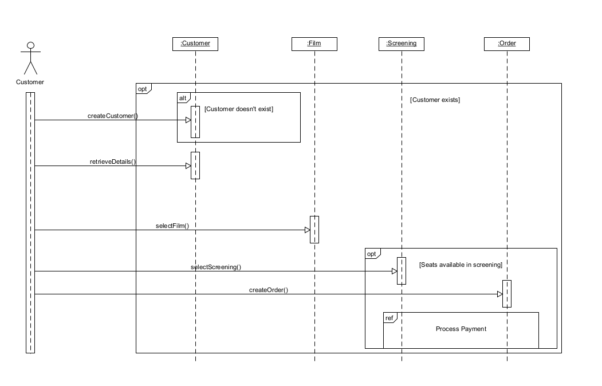

Consider the object order. To begin with an order is a new order once payment has been processed it is a paid order. At some time before the screening of the order seats will be assigned to the order and it is now considered filled. When the customer collects the tickets for the order the order is now considered closed. The customer can cancel a paid or a filled order up to twenty four hours before the screening and it is now a cancelled order. If the cancellation time is less than twenty four hours before the screening the order will remain in its current state. A cancelled order will become a refunded order when the refund has been processed. Refunded and closed orders are deleted from the system after a week

Draw a behavioural state machine for this object.

(50 Marks)

